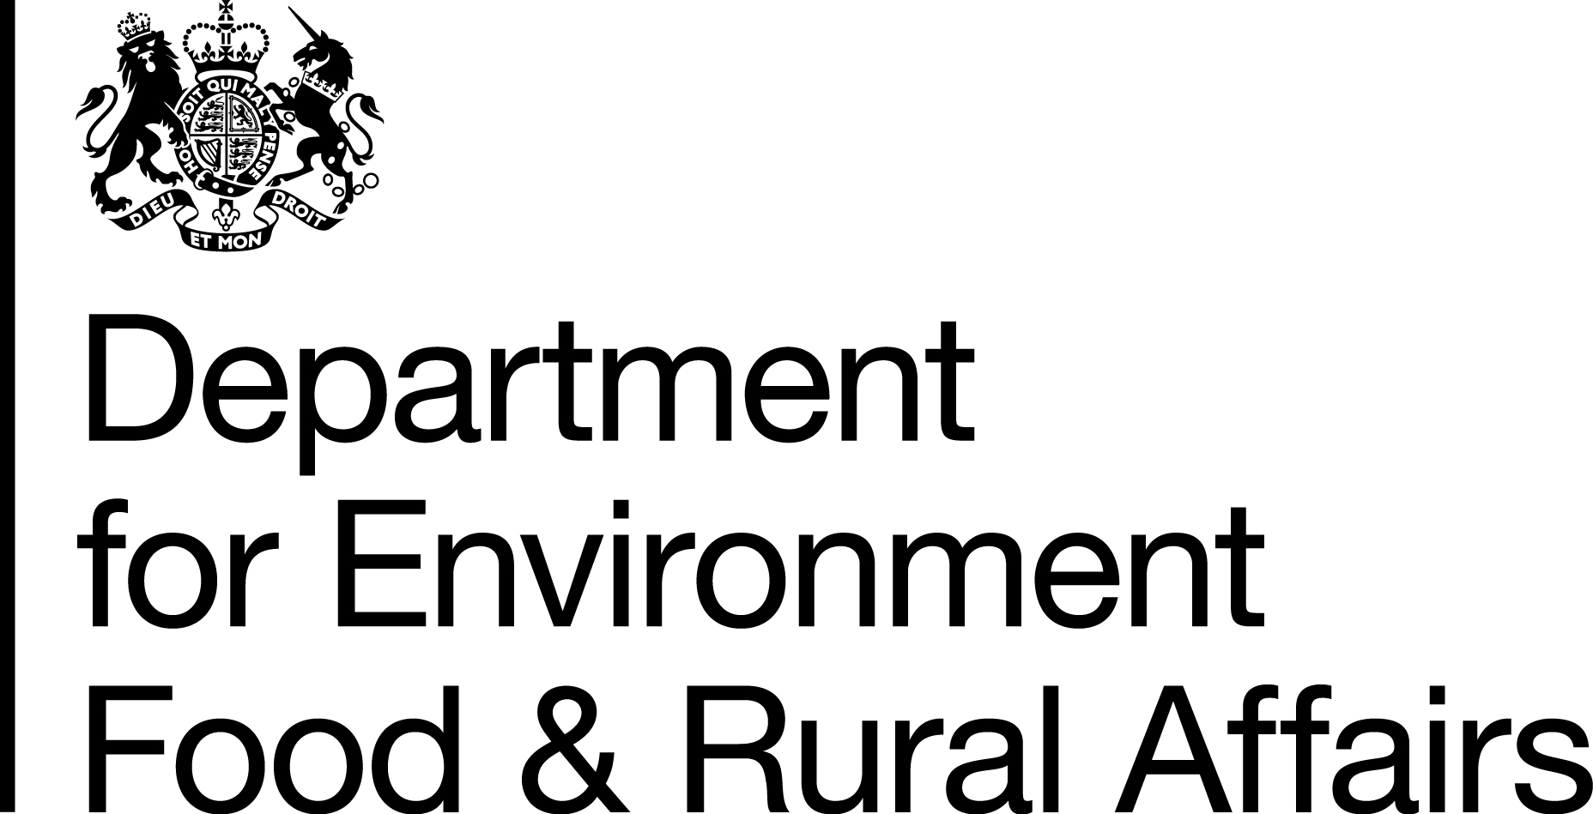

Farming in Protected Landscapes Programme

Application form

Before you begin:
- Contact the Farming in Protected Landscapes (FiPL) Officer.
- Read the accompanying application guidance

FiPL Officer: | Name: | Rebecca Williams (Environment & Sustainability Officer)  Council of the Isles of Scilly. On behalf of the Isles of Scilly AONB Partnership
 | Tel: | 01720 424400
 | E-mail: | rebecca.williams@scilly.gov.uk

Please skip to Section 1 if your application is not part of a collaborative farmer group application.

Applications can be made for collaborative farmer groups and the process for doing so is outlined in the application guidance. If you are applying on
behalf of a collaborative farmer group please complete the below box prior to beginning your application.

Please select one of the following options to outline  why you are applying on behalf of the collaborative  farmer group: | ☐ I am the lead applicant who will be distributing the resources to the group, managing the application process and reporting on the progress of the project.  ☐ I am a member of a third party, not part of the collaborative farmer group but acting on their behalf. The third party will distribute the resources to the group, manage the application process and report on the progress of the project.  ☐ I am a member of the Protected Landscape body, not part of the collaborative farmer group but acting on their behalf. The Protected Landscape body will distribute the resources to the group, manage the application process and report on the progress of the project.
Evidence of partnership agreement (s) between the participants in the farmer collaborative group and the
lead applicant/third party/Protected Landscape will need to be demonstrated for an application to proceed.

Applications will not be progressed unless partnership agreement (s) can be evidenced.

Have you secured partnership agreement (s) with all  participants in the collaborative farmer group and  yourself/your organisation?  You must answer yes for your application to proceed. | ☐ Yes  ☐ No
Have you provided evidence of these partnership  agreement (s)? | ☐copy of partnership agreement (s) enclosed  ☐copy of partnership agreement (s) to follow

Section 1) Information about you and your project

Your application will not be scored on your answers in this section.

Details of the person making the application
Full name of the main contact |  |  |  |  | Position in business
Daytime telephone number |  |  |  |  | Email address
Business Name (this can be the name of the farm/land management/business/organisation name)
Business address (including the postcode)
Location and grid reference of the project if different from the address above. Please include a postcode.
Single Business Identifier (SBI) number (if applicable)
Parcel ID(s) in RLR format (e.g. AB1234 5678) (if applicable)
What is the area being funded for the activity in the parcel (s) in hectares? (if applicable)
Website address (if applicable)
Which option best describes you? Tick one option.
Company |  | ☐ | Sole trader | ☐ |  | Private Individual |  |  | ☐
Partner |  | ☐ | Other | ☐ |  | If other, please state what type
What are the main activities of your business?  Tick all that apply. |  |  | Dairy |  | ☐ |  | Beef |  |  | ☐
 |  |  | Sheep |  | ☐ |  | Arable |  |  | ☐
 |  |  | Forestry |  | ☐ |  | Public access |  |  | ☐
 |  |  | Diversification |  | ☐ |  | Other |  |  | ☐
 |  |  | If other, please describe
If a farm/land management business is involved, please provide the size of the farm and how much land is classified as Severely Disadvantaged Area (SDA). |  |  | Area of the holding (hectares) |  |  |  | Area of the holding in the SDA (hectares)
Is this a collaborative farmer group application?  If yes, what are the names and roles of group members?  If your group has a constitution, please email/include this with your application |  |  | ☐ Yes ☐ No
Double Funding
Have you received or applied for any other funding for the same activities you are applying for in this programme?  This might include:  - Environmental Stewardship  - Countryside Stewardship Schemes  - Protected Landscape  - Growth Programme,  - LEADER  - Countryside Productivity  - Green Recovery Challenge Fund  You cannot get funding for activities or works that you are already getting funding for (or have already got funding for) from another agri-environmental scheme, This would be called double funding. |  |  | ☐ Yes ☐ No  If yes, please explain why you do not consider this double funding:
Do you get any agricultural or non-agricultural subsidies? |  |  | ☐ Yes ☐ No  If yes, which agricultural or non-agricultural subsidies?
If yes, is the total amount, including this grant offer, more than £350,000 over the last 3 years?
☐ Yes ☐ No
Is any of the work you plan to do covered by an insurance claim or as a condition or part of a condition of planning permission?  Work covered by an insurance claim or planning permission is not eligible for funding. You must make this clear in the project costs and funding section of this application. |  |  | ☐ Yes, as an insurance claim
 |  |  | ☐ Yes, as a condition of planning permission

Site details

Where possible, please attach a map showing the project location.
Do you, or someone else you are applying with, own and manage the land where the project is taking place? |  |  |  | ☐ Yes ☐ No
If no, do you have the written approval from the landowner(s) involved in the project?  You cannot submit this application without permission from the landowner. |  |  |  | ☐ Yes ☐ No
If yes, you will need to provide written permission from the landowner. |  |  |  | ☐ permission uploaded with application ☐I will send a copy separately
Do you or someone else you are applying with have a lease or tenancy? |  |  |  | ☐ Yes ☐ No
If yes, | What type of lease or tenancy?
 | How long is the tenancy? |  |  | Length of tenancy in years
 | How long is remaining in the tenancy? |  |  | Time remaining in years and months
Does your project need any other permissions? For example:  - Site of Special Scientific Interest (SSSI) consent  - agri-environment scheme approval  - planning permission  - water abstraction license  - Forestry Commission impact assessment for tree establishment/woodland creation  - Scheduled monument consent  If your application for funding is approved, you must provide a copy of the permissions before you can start any works.  Your Protected Landscape FiPL officer should be well placed to advise on any permissions your project may require. Please speak to them about permissions prior to submitting an application. |  |  |  | ☐ Yes ☐ No  ☐ permission uploaded with application ☐I will send a copy separately
Will the project be delivered on a protected site, for example SSSI? If yes, give details of the site and protection. |  |  |  | ☐ Yes  ☐ No
If applicable, what is the area of your holding that will be covered by the project (hectares)?
Project timescale
Project start date
Project end date
Have you received funding from the Farming in Protected Landscapes Programme in the past? |  |  |  | ☐ Yes ☐ No
If yes, how much funding and when did you get it?

Section 2) Information about the project

Your application will be scored on your answers in this section.
Applications will be scored against each of the following categories:
- Project outcomes
- Value for Money
- Sustainability / legacy of projects
- Ability to deliver

You can find more information in the guidance. [PLs to provide a link to the guidance]

Project details
Project name
Objective of project
There are several outcomes that this programme is aiming to deliver on, across four key themes; Climate, Nature, People and Place.
You can find out more about the themes and outcomes in the guidance.

You project must deliver against at least one of these outcomes. For each theme, tick any outcomes your project will deliver against.

Theme: Climate | ☐ More carbon is stored and/or sequestered  ☐ Flood risk has been reduced  ☐ Better understanding among farmers, land managers and the public as to what different habitats and land uses can deliver for carbon storage and reduced carbon emissions  ☐ The landscape is more resilient to climate change
Theme: Nature | ☐ There is a greater area of wildlife rich habitat  ☐ There is greater connectivity between habitats  ☐ Existing habitat is better managed  ☐ There is an increase in biodiversity
Theme: People | ☐ There are more opportunities for people to explore, enjoy and understand the landscape  ☐ There are increased opportunities for more diverse audiences to explore, enjoy and understand the landscape  ☐ There is greater public engagement in land management, for example through volunteering
Theme: Place | ☐ The quality and character of the landscape is reinforced or enhanced  ☐ Historic structures and features are conserved, enhanced or interpreted more effectively  ☐ There is an increase in the resilience of nature friendly sustainable farm businesses, which in turn contributes to a more thriving local economy
Describe your project.
You should aim to say something about each of the following things:

- An outline your project
- What your project will deliver
- How your project will achieve the outcomes you have selected above
- What will the results of your project will be
- What the need for your project is
- The opportunity your project will present

(max 500 words)
How will your project support the local priorities and management plan of the Isles of Scilly AONB? Your project must support the priorities of the Protected Landscape you are delivering in.
You should read the AONB local priorities and management plan before answering this question.

(max 250 words)

Who will be involved in delivering the project and what will their roles be?
If your project needs to be promoted, how will you do this?
For example, if you are converting a barn for educational visits, how will you promote the barn to get visitors?
(max 200 words)
What will happen to the project once the funding ends?
You should aim to say something about how you will:
- Make sure the project is sustainable
- Make sure that the skills and knowledge developed whilst delivering your project are embedded longer-term

(max 200 words)

Project costs and funding
You must discuss your project with your Farming in Protected Landscapes engagement lead before you start this section.
Are you VAT registered? | No ☐ | Yes ☐ |  |  | If yes, what is your VAT number:
If you are able to reclaim VAT, please exclude this from the figures given in this section
If you are not VAT registered, you should complete the “Not registered for VAT” form (found at the end of this Application Template). You will be able to include VAT in the figures given below.
What is your total project cost?
Do you confirm you will ensure funding is used for the intended purpose? |  |  | ☐ Yes ☐ No
How do you know your project provides a cost-effective way of delivering the outcomes?
For example, are your costs based on Countryside Stewardship rates, quotes or other published standard rates?
Does your project have any matched funding?  This can improve your application’s value for money score. |  |  | ☐ Yes ☐ No
If yes, |  |  | What is the value of your match funding?
 |  |  | Has your match funding been secured? |  |  |  |  |  | ☐ Yes ☐ No
Please list your project costs and where necessary including three quotes for activities as advised by your Protected Landscape Farming in Protected Landscape Programme officer (contact details at start of form). For the quotes, where the chosen supplier of a product or service is not the cheapest available, please provide an explanation as to why you have opted for the higher quotation.
Your Protected Landscape Farming in Protected Landscape Programme officer can help with this section.
(insert rows or continue using a separate sheet as necessary)
Item |  |  | Capital  Please tick | Revenue  Please tick |  | Item cost (£) | FiPL Payment rate  (as advised by Isles of Scilly AONB Partnership | FiPL Intervention Rate  (as advised by Isles of Scilly AONB Partnership |  | FiPL Grant Request (£) | Funding from additional sources such as match funding (£)  (if required)
 |  |  | ☐ | ☐
 |  |  | ☐ | ☐
 |  |  | ☐ | ☐
 |  |  | ☐ | ☐
Total FiPL Grant Request (total amount of funding you are applying for) |  |  |  |  |  |  |  |  |  | £ ……………..
Total cost of project (this is your FiPL grant request and any additional funding you have secured) |  |  |  |  |  |  |  |  |  | £ ……………..
Project evaluation
How will you evaluate the success of your project?
Briefly tell us how you plan to measure progress against your outcomes/outputs and how you will baseline your starting point.
(max 500 words)
☐ I confirm that I will work with my local Protected Landscape team to participate in a proportionate project evaluation and if required feed into programme evaluation led by external evaluator.

Declaration
I declare that the information given above is correct to the best of my knowledge, and that if any of the information changes, I will inform the [PL to insert] organisation immediately.

Name………………………………………….

Position……………………………................
Signed…………………………………………

Date……………………………………………
What to do next?
You must sign your application form before it can be processed.
If you have added an electronic signature to the declaration then you can email it to rebecca.williams@scilly.gov.uk.
If you cannot add an electronic signature you should print and sign this application and send it to:

Rebecca Williams
Council of the Isles of Scilly
Environment Service
Town Hall
St Marys
Isles of Scilly
TR21 0LW

Please return this form to:
- Electronically to: rebecca.williams@scilly.gov.uk
- Postal to:
Rebecca Williams
Council of the Isles of Scilly
Environment Service
Town Hall
St Marys
Isles of Scilly
TR21 0LW
Optional: To help us publicise in the future, please tell us where you heard about the programme.

Privacy Statement

In submitting your application and declaring the above information correct, you consent to the Isles of Scilly AONB Partnership sharing any information provided to the Department for Environment, Food and Rural Affairs (Defra) – including their arm’s length bodies, including Rural Payments Agency, Natural England and Forestry Commission – for the monitoring of the programme and to complete dual funding check processes.

With respect to the processing of Your personal data, the Isles of Scilly AONB Partnership, Defra and its arm’s length bodies will implement and maintain appropriate technical and organisational measures to ensure a level of security appropriate to that risk, including, as appropriate, the measures referred to in Article 32(1) (a), (b), (c) and (d) of the retained EU law version of the General Data Protection Regulation (Regulation (EU) 2016/679), transposed into UK Law by the Data Protection, Privacy and Electronic Communications (Amendments etc) (EU Exit) Regulations 2019).

You can read the Council of the Isles of Scilly’s Corporate Privacy Notice here:
Corporate Privacy Notice V2 FINAL.pdf (scilly.gov.uk)
Not Registered for Value Added Tax (VAT) Form
Applicant name (main contact)
Name of project

I am / we are not registered for the purposes of Value Added Tax because:
(a) I am / we are not eligible to register; or
(b) I / we have decided not to apply for voluntary registration
Delete as appropriate.

Declaration
I / we hereby declare that I am / we are not registered or about to be registered for the purposes of Value Added Tax and that I / we have not claimed and will not claim deduction or repayment as input tax of any amounts of VAT included in the price paid for the following works or facilities which are the subject of the claim made by me / us on:
Delete as appropriate.

Date: …………….…………………………………………….

List of works or facilities covered by the above-mentioned claim:
See: Project costs and funding

Signed ………………………………………………… Date……………………………….

Name in BLOCK LETTERS…………………………………………………………………

On behalf of ………………………………………………………………………………………

Notes:
- If you obtain or attempt to obtain by deception grant for yourself or anyone else, you may be liable to a fine and/or imprisonment.
- A false or misleading statement, whether made by the applicant or authorised agent, may mean that approval will be revoked and any grant may be withheld or recovered.

